  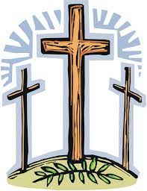

**Family Event**

**Good Friday 18th April 10am to noon**

**In The Stables**

This event is aimed at children aged 0 to 8 years accompanied by parents.

We will be sharing the events of Palm Sunday, Maundy Thursday and Good Friday through crafts, storytelling and song.

We will begin in The Stables, then have a short service in church and end with refreshments in The Stables.

Please contact [karen_baylis@hotmail.co.uk](mailto:karen_baylis@hotmail.co.uk) should you require any more information.

We look forward to seeing you all.

